Er RAJAT KALIA
(B.TECH IIT-Delhi)
PH. 9815439805
Er MANISH KALIA
B.TECH (Delhi COLLEGE OF ENGINEERING)
PH. 09990074601,9878146388

9DE

INTRODUCTION

Sequence and Series is one of the most important chapter that is covered in the syllabus for IIT-JEE. The summation of series is one of the most important way to reduce large series into some value and it is widely used throughout the syllabus. The tricks and techniques discussed here are very useful and are widely used in other chapters as well. The A.M- G.M inequality which will be discussed here is also a very important result that is used widely.
So Let us Probe more into this Chapter...

Arithmetic Progression (A.P):
A sequence of numbers is said to be in A.P when difference is constant for all
n ∈ N. This constant is called common difference. If a the first term and d the common difference of the A.P then,
1) n^{th} term t_{n} = a+ (n-1) d.
Proof
1st term of A.P = a = a+ (1-1) d.
2nd term of A.P = a+d = a+ (2-1) d.
3rd term of A.P = a+2d = a + (3-1) d.
4th term of A.P = a+3d = a + (4-1) d.
∴ n^{th} term of A.P = a + (n-1) d.
2) Sum of n terms
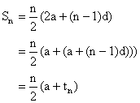
Why?
Let S_{n} = a + (a+d) + (a+2d) + ------- + a+ (n-2) d + a+ (n-1) d --------- (1)
Or S_{n} = a+ (n-1) d + a+ (n-2) d + ------------ + (a+d) + a ---------- (2)
Now adding (1) and (2) we get
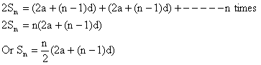
Arithmetic Means (A.M):
The n number A₁, A₂, A₃---------, A_{n} are arithmetic means between a and b if a, A₁, A₂, -----A_{n}, b are in A.P.
Since a is first term and b is (n+2) ^{th} term.
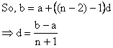
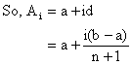
Note:
1) 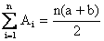
Why?
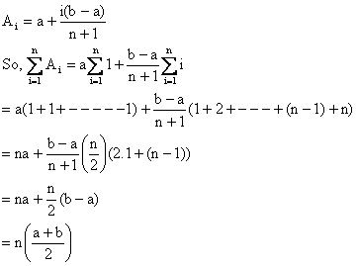
2) Arithmetic mean A of n numbers a₁, a₂, ----------- a_{n} is given by,
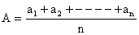
Illustration 1:
For what value of n 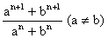is A.M between a and b?
A.M between a and b is 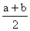
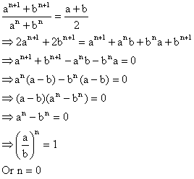
Properties of A.P:
1) If a fixed number is added (substracted) to each term of a given A.P. then resulting sequence is also A.P with same common difference as given A.P.
Dumb Question:
1) Why common difference has not changed?
Ans: Suppose the original A.P had , now let g be substracted from each term. So . Therefore only the first term of A.P has changed.
2) If each term of an A.P is multiplied (or divided) by fixed constant then resulting sequence is also an A.P with common difference multiplied (or divided) by same constant.
3) Sum and difference of corresponding terms of two A.P’s will form an A.P.
Why?
Let first A.P be
And second A.P be
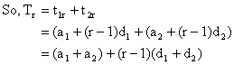
So, resulting sequence is A.P with first term a₁+a₂ and common difference d₁+d₂.
4) If we want to pick terms of an A.P then convenient way of doing that is,
For three term’s in A.P we choose a-d, a, a+d.
For four terms in A.P we choose a-3d, a-d, a+d, a+3d.
5)
6) If a, b, c are in A.P ⇒ 2b = a+c or b-a = c-b.
7) The sum of the terms of an A.P equidistant from beginning and end is constant and equal to sum of first and last term.
= Constant = .
Illustration 2:
Find the number of terms in the series 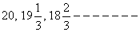of which the sum is 300.
Solution:
Here we observe that a=20, 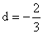, and S_{n} = 300.
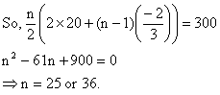
Dumb Question:
1) Why do we get n as 25 and 36 both?
Ans: This clearly indicates that sum of terms from n = 26 to 36 is zero.
i.e.
Geometric Progression:
A sequence is a G.P when its first term is non-zero and each of its succeeding term is r times the preceding term. The fixed term r is known as common ratio of G.P.
If a is first term of an G.P and r its common ratio then,
1) n^{th} term .
Why?
Let us observe the pattern
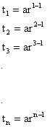
So, clearly .
2) The sum of first n terms
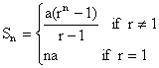
Why?
Case 1: Suppose r=1
So,
= na
Case 2: If r ≠ 1.
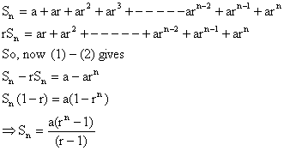
3) If |r|<1 and n→ ∞ then 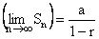
Why?
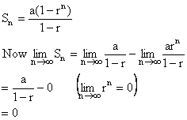
Dumb Question:
1) Why r^{n}=0?
Ans: Here |r|<1 so as we multiply r by itself so the value goes down and down. For example. Suppose r = ½, so r²=1/4 is less than ½ and so the value keeps going down.
Illustration 3:
If a₁, a₂, a₃ are 3 consecutive terms of a G.P with common ratio k and a₁<0. Find values of k for which a₃> 4a₂-3a₁ is satisfied.
Solution:
Now since a₁, a₂, a₃ are in G.P
So a₂ = a₁k.
a₃ = a₁k².
∴ a₁k² > 4a₁k-3a₁.
⇒ a₁ (k²-4k+3) > 0.
Or a₁ (k-1) (k-3) > 0.
Since a₁<0 so it means (k-1) (k-3) < 0.
⇒ 1<k<3.

Geometric Means (G.M)
If G₁, G₂, G₃, G₄---------G_{n} are in G.M’s between a and b then a, G₁, G₂, ----------- G_{n}, b are in G.P.
Now b is t_{n+2} so b = ar^{n+1}
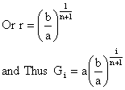
Note:
1) The product of n G.M’s between a and b is equal to n^{th} power of one G.M between a and b
i.e. G₁, G₂------- G_{n} = .
Why?
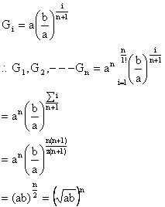
2) If a₁, a₂, ------- a_{n} are n non-zero numbers then their G.M is given by
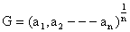
Illustration 4:
If we insert odd number (2n+1) G.M’s between 4 and 2916 then find the value of (n+1) ^{th} G.M?
Solution:
Now 4, G₁, G₂, G₃----------- G_{n+1}, ------- G_{2n}, G_{2n+1}, 2916 are in G.P. So G_{n+1} will be the middle mean of (2n+1) odd means and so it will be equidistant from 1st and last term.
So, 4, G_{n+1}, 2916 are also in G.P.
And thus,
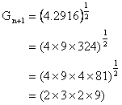
= 108.
Properties of G.P:
1) If each term of a G.P is multiplied (or divided) by some non-zero quantity the resulting progression is G.P with some common ratio.
Why?
Suppose the G.P is with
Now this G.P is multiplied by some k (≠0).
So G.P will be
So, only the first term of G.P has changed and the common ratio remains unaffected.
2) If a₁, a₂, -------- and b₁, b₂, ---------- be two G.P’s of common ratio r₁ and r₂ respectively, then a₁b₁, a₂b₂, ------ and 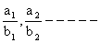will also form G.P common ratio will be r₁r₂ and respectively.
Why?
Let the series a₁, a₂--------- have the n^{th} term as and the series b₁, b₂-------- have n^{th} term as .
So the series a₁b₁, a₂b₂ ------- will have n^{th} term as
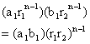
So the common ratio now becomes r₁r₂.
3) If we have to take three terms in G.P we take them as 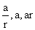with common ratio r and four terms as 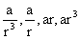with common ratio r².
4) If a, b, c are in G.P then b² = ac.
5) If a₁, a₂, a₃ -------- a_{n} is a G.P then loga₁, loga₂--------- loga_{n} is an A.P.
Why?
Now a₁, a₂, a₃ ------- a_{n} form a G.P.
So
This is clearly term of an A.P.
Dumb Question:
1) How does loga₁ + (i-1) logr represents term of an A.P?
Ans: Let loga₁ = A
And logr = D
So, loga₁+ (i-1) logr = A+ (i-1) D.
So, A+ (i-1) D is term of an A.P with first term as A and common difference as D

Illustration 5:
If x = 1+ a+ a²+a³+ --------+∞ and y = 1+b+b²+ b³+ ------ +∞ Show that,
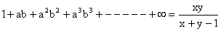
Where 0<a<1 and 0<b<1.
Solution:
Given x = 1+ a+ a²+a³+ --------+∞
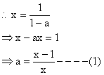
y = 1+b+b²+ b³ ------ +∞
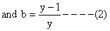
Since 0<a<1, 0<b<1
∴ 0<ab<1.
Now 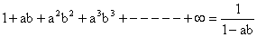
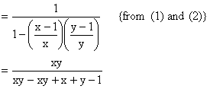
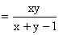

Arithmetic Geometric Series (A.G.P):
Suppose a₁, a₂, a₃, ------- a_{n} be an A.P and b₁, b₂, b₃, ------- b_{n} is a G.P Then the sequence a₁b₁, a₂b₂, -------- a_{n}b_{n} is A.G.P.
A.G.P is of form
Where clearly
1) Sum of n terms of an A.G.P
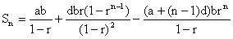
Why?
Let
Now if we multiply the series by r then.
So on substraction,
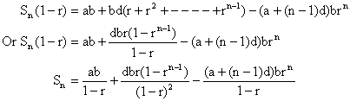
2) Sum of infinite series S∞.
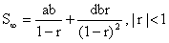
Why?
If |r|<1 then
So, 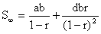
Illustration 6:
If sum to infinity of the series 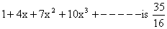then find x.
Solution:
We know that
Here a=1, b=1, r=x, d = 3
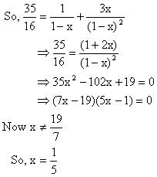
Dumb Question:
1) Why 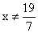?
Ans: For infinite series to be summable |x| needs to be less than 1 hence

Harmonic Progression (H .P):
The sequence a₁, a₂, ------ a_{n} is said to be a H.P if 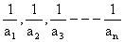is an A.P.
The n^{th} term of a H.P (t_{n}) is given by 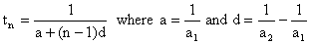.

Harmonic Means (H .M):
If H₁, H₂, H₃-------- H_{n} be n H.M’s between a and b then a, H₁, H₂, H₃-------- H_{n}, b is a H.P.
This means 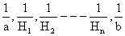is a A.P.
And hence 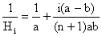
Note:
1) If a₁, a₂, a₃---------a_{n} are n non-zero numbers then H.M(H) of these number is given by
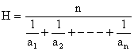
2) If a, b, c are in H.P then 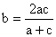
Why?
a, b, c are in H.P so, 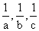are in A.P
And hence 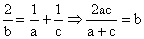
Illustration 7:
If the (m+1)^{th}, (n+1)^{th} and (r+1)^{th} term of an A.P are in G.P m, n, r are in H.P, Show that ratio of the common difference to the first term in the A.P is (-2/n).
Solution:
Let ‘a’ be the first term and ‘d’ be common difference of the A.P. Let x, y, z be the (m+1)^{th}, (n+1)^{th} and (r+1)^{th} term of the A.P then x = a+md, y = a+nd, z = a+rd. Since x, y, z are in G.P.
∴ y² = xz i.e. (a+nd)² = (a+rd) (a+md)
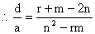
Now m, n, r in H.P
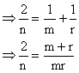
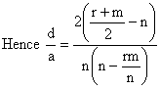
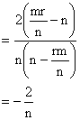

Some Important Theorems:
If A, G, H are respectively AM, GM, HM between two positive unequal quantities then.
1) A>G>H
Why?
First of all let us Prove A>G.
The two numbers be x, y.
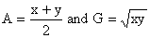
So to prove 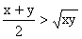
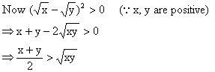
Hence A>G -------- (1)
Now Let us Prove G>H
Again 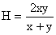
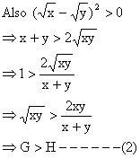
Combining (1) and (2) we get A>G>H.
Why G²=AH?
Let x, y be two numbers.
So, 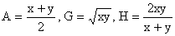
Hence
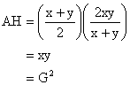
Illustration 8:
If a, b, c, d, be four distinct positive quantities in H.P then show that a+d>b+c.
Solution:
a, b, c, d are in H.P
Then A.M > H.M
For first three terms 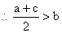
⇒ a+c>2b ------ (1)
And for last three terms
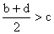
⇒ b+d > 2c ------ (2)
From (1) and (2)
a+c+b+d > 2b+2c
⇒ a+d > b+c.

Some Special Series:
1) 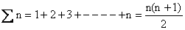.
Why?
This is an A.P with a =1 and d=1
So, 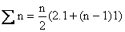
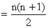
2) 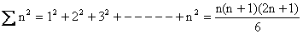
Proof:
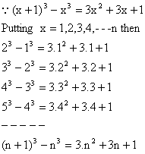
Adding all we get,
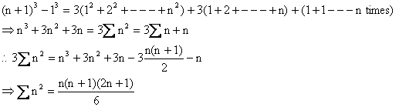
3) 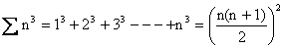
Proof:
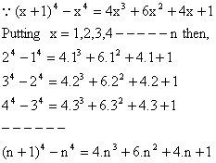
Adding all we get,
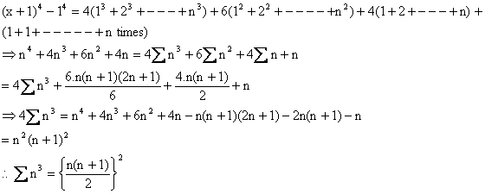
Illustration 9:
If S₁, S₂, S₃, ------- S_{n} are the sums of infinite geometric series whose first term are 1, 2, 3, --------n and whose common ratios are 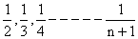respectively then find the value of 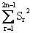.
Solution:
The r^{th} series has the first term a = r.
Common ratio = 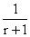, Sum = S_{r}.
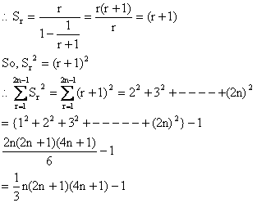
Some Special Series:
1) Method of Difference:
Suppose a₁, a₂, a₃--------- is a sequence such that sequence a₂-a₁, a₃-a₂, -------- is either an A.P or a G.P. Then n^{th} term of this sequence may be found as follows:
Let
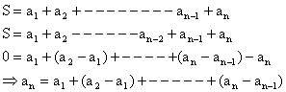
So, we find value of a_{n} and hence S_{n}.

Dumb Question:
1) How do we ensure that value of a_{n} can be calculated?
Ans: The terms form either an A.P or a G.P. So we can always sum them up.
2) Method of V_{n}:
Let T₁, T₂, T₃------- be terms of a sequence. If there exists a sequence V₁, V₂, V₃---------- Satisfying then,
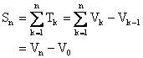
Illustration 10:
. Then find the sum to infinite terms of the series on the left hand side.
Solution:
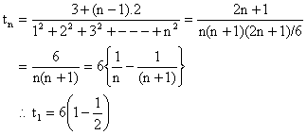
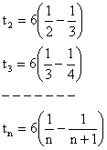
Adding L.H.S = 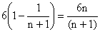
Thus 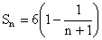
∴ Sum of infinite terms
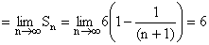
PROBLEMS (EASY TYPE)
1) If the roots of the equation are in A.P then what will be their common difference?
Solution:
Sum of three numbers a-d, a, a+d are in A.P.
= 3a = 12
∴ a = 4 is a root of cubic
∴ (x-4) (x²-8x+7) = 0
∴ x = 1, 4, 7 or 7, 4, 1 and d = ±3.
2) The sum of the squares of three distinct real numbers which are in G.P is S² if their sum is αS, show that 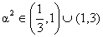.
Solution: Let the three numbers in G.P is 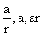
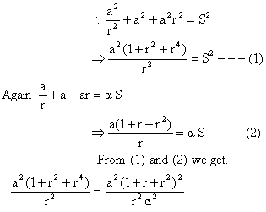
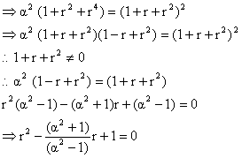
Since r is real 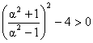{the number in G.P are different}.
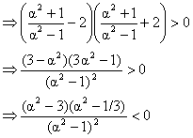
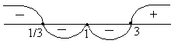
Fig (1)
Critical points of α² are 1/3, 3, 1 from wavy curve method.
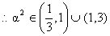
3) Find the sum
1.2.3.4.5+2.3.4.5.6+3.4.5.6.7+-------+ (n-4) (n-3) (n-2) (n-1) n
Solution:
The given sum = 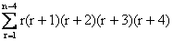
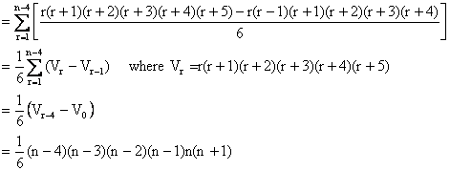
3) Prove that natural number 7.7.7------7 consisting of seven is a composite number divisible by a multiple of 7.
Solution:
7.7.7------7 = 7×1.1.1----1
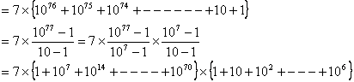
= 7×integer×integer.
4) If a, b, c are in H.P and b, c, d are in G.P and c, d, e are in A.P show that
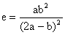
Solution:
Given a, b, c are in H.P
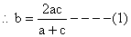
b, c, d are in G.P
And c, d, e are in A.P
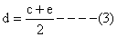
We want the relation in a, b, e
Then eliminate c, d from (1), (2) and (3)
From (1) ab+bc = 2ac
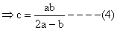
From (3) and (4)
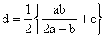
Substituting the values of c and d from (4) and (5) in (2) we get,
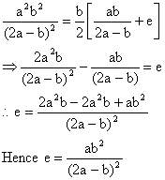
5) Balls are arranged in rows to form an equilateral triangle the first row consist of one ball, the second row of two balls and so on. If 669 more balls are added then all the balls can be arranged in the shape of a square and each of the sides then contains 8 balls less than each side of the triangle then find the initial number of balls.
Solution:
S = 1+2+3+4+-------+n = 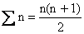
S+669 = (n-8)² by given condition
Or 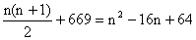
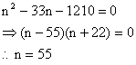
∴ S = 1540.
Check: 1540+669 = 2209 = (55-8)² = (47)².
6) The equation has four positive roots then find the value of (p, q).
Solution: Let the roots be α,β, γ, δ.
∴ α+ β+ γ+ δ = 4. and α.β.γ.δ = 1.
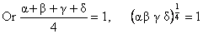
∴ A.M = G.M of the roots
∴ All the roots are equal and each equal to 1.
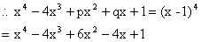
Comparing we get p = 6, q = -4.
7) If a₁, a₂, a₃, --------- a_{n} are in A.P where a_{i} ≠ kπ for all i, prove that
Cosec a₁.Cosec a₂ + Cosec a₂.Cosec a₃ + --------+Cosec a_{n-1}.Cosec a_{n} = 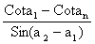
Solution:
L.H.S = 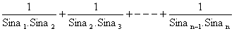
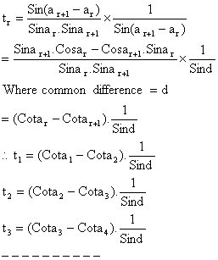
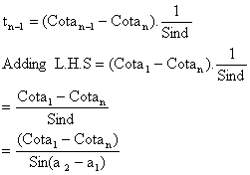
8) Prove that 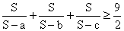if S = a+b+c [a, b, c>0].
Solution:
We have to prove
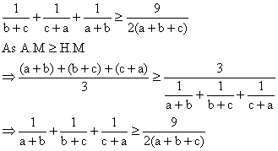
9) Two consecutive numbers from 1, 2, 3-------n are removed. Arithmetic mean of the remaining numbers is . Find n and those removed number.
Solution:
Let p and (p+1) be removed numbers from 1, 2, 3, ------ n then sum of remaining numbers.
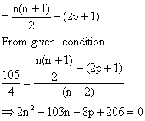
Since n and p are integers so n must be even let n=2r.
We get 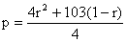
Since p is an integer then (1-r) must be divisible by 4.
Let r = 1+4t we get
n = 2+8t and p = 16t²-95t+1.
Now 1≤p<n.
⇒ 1≤ 16t²-95t+1< 8t+2.
⇒ t = 6.
⇒ n = 50 and p = 7.
Hence removed numbers are 7 and 8.
10) Find the sum of infinitely decreasing G.P whose third term, the triple product of the first term by the fourth term A.P with the common difference equal to 1/8.
Solution:
Let G.P be a, ar, ar²------ Since the G.P is infinite and decreasing -1< r< 1 and r>0, so 0< r<1 and so a>0 according to the hypothesis.
ar², 3a ar³, ar are in A.P with common difference 1/8.
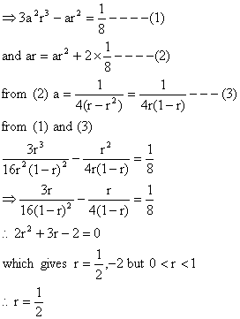
From (3) we get a = 1
Hence G.P is 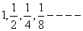
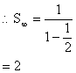
PROBLEMS (MEDIUM TYPE)
1) A sequence a₁, a₂, a₃, ------- a_{n} of real numbers is such that a₁= 0, |a₂| = |a₁+1|, |a₃| = |a₂+1|, ---------- |a_{n}| = |a_{n-1}+1|. Prove that arithmetic mean of a₁, a₂, -------- a_{n} can not be less than -1/2.
Solution:
Let us add one more number a_{n+1} to the given sequence. The number a_{n+1} is such that |a_{n+1}| = |a_{n}+1|.
Squaring all numbers we have,
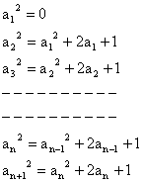
Adding the above equalities we get,
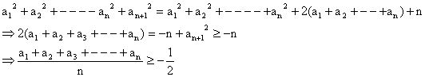
Dumb Question:
1) Why ?
Ans: a_{n+1} is given to be a real no in the question and hence is going to be a positive number.
There fore .
2) There are (4n+1) terms in a certain sequence of which the first (2n+1) terms form an A.P of common difference 2 and the last (2n+1) terms are in G.P of common ratio 1/2. If the middle terms of both A.P and G.P be the same what is the mid term of this sequence.
Solution: d=2, r=1/2
If there be odd number of terms then mid term = 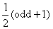.
T_{2n+1} is the mid term of sequence of (4n+1) odd terms a+2nd = a+4n ------ (1)
This mid term is the last term of A.P and first term of following G.P. Each of (2n+1) terms with this term being common to both.
T_{n+1} and t_{n+1} are mid terms of A.P and G.P
T_{n+1} = a+nd = a+2n.
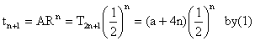
By given condition T_{n+1}= t_{n+1}.
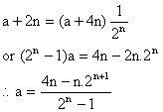
Hence mid term of sequence by (1) is
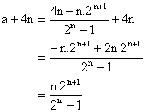
Dumb Question:
1) Why middle term of the G.P is 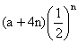?
Ans: Well the first term of the G.P is the last term of the A.P
So, the first term = a+2(2n+1-1)
= a+4n.
Now the (n+1)^{th} term of the G.P is
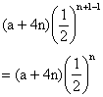
3) If 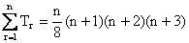then find 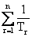.
Solution:
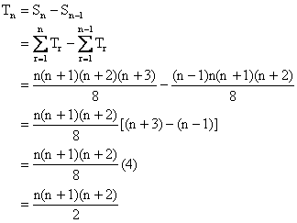
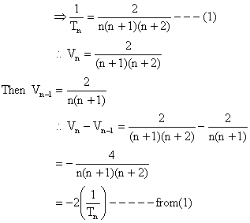
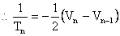
Putting n = 1, 2, 3, ------n
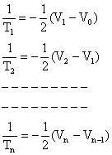
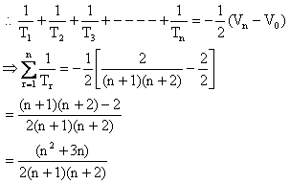
4) Evaluate sum of n terms of the series 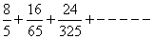
Solution:
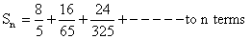
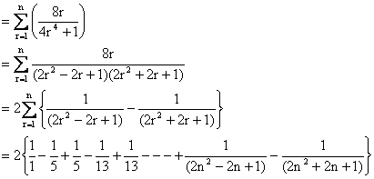
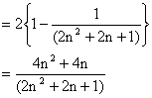
5) Find the sum of 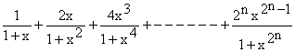
Solution:
If S be the sum then consider 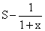
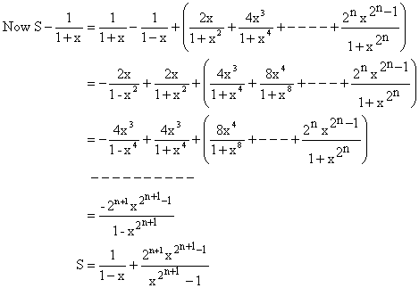
6) If 2a+b+3c = 1 and a>0, b>0, c>0 find the greatest value of and obtain the corresponding values of a, b, c.
Solution:
Consider the positive numbers 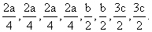{As there is a⁴, take 4 equal parts of 2a; as there is b² take 2 equal parts of b; as there is c² take 2 equal parts of 3c}.
For the numbers,
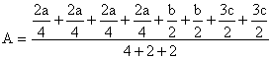
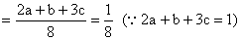
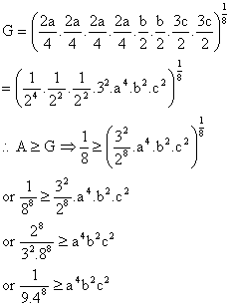
So the greatest value of = 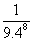
Now when the value is greatest the numbers themselves have to be equal.
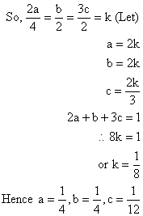
7) If where x∈R then find 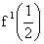.
Solution:
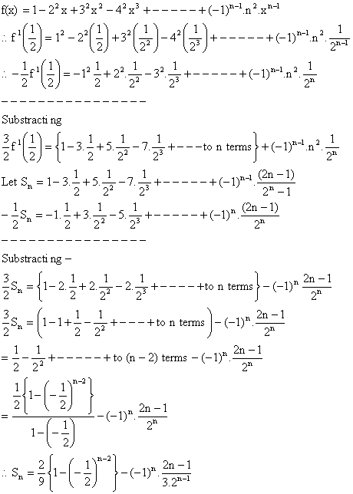
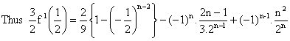
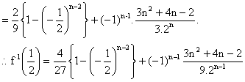
8) Let S_{n}, n=1, 2, 3, ------- be the sum of infinite geometric series whose first term is n and the common ratio is 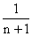evaluate.
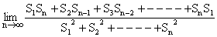
Solution:
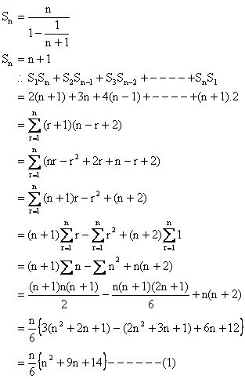
And
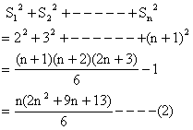
From (1) and (2) we get,
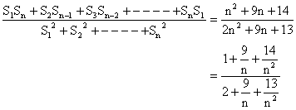
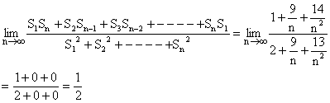
Dumb Question:
1) 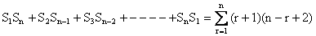
Ans:
S_{n} is n+1
So, S_{r} = r+1.
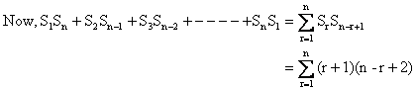
9) Prove that the numbers of the sequence 121, 12321, 1234321, ----- are each a perfect square of odd integer.
Solution:
We have first term T₁ = 121 = 10² + 2×10 + 1
Second Term T₂ = 12321 = 10⁴ +2×10³ + 3×10² +2×10+1.
Third Term
------------------------------------------------
n^{th} term T_{n} = 123---------- n (n+1) n ---------- 4321
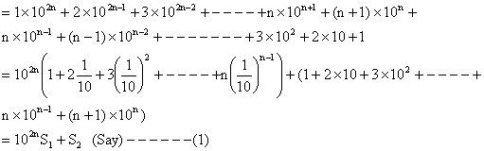
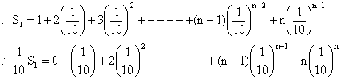
Substracting we get,
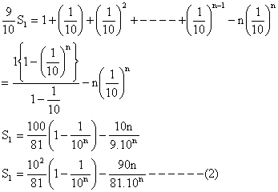
And
Substracting we get,
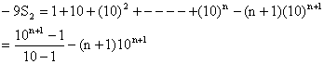
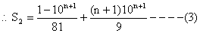
Substituting the values of S₁ and S₂ from (2) and (3) in (1) we get
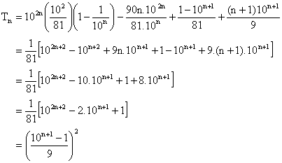
Since sum of digits of is divisible by 9.
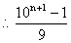is a positive integer.
Thus T_{n} is a perfect square.
10) Sum to n terms:
Solution:
Regrouping the terms the series becomes
The number of terms in each group will depend on n.
If n=3m i.e. n is divisible by 3
Sum of the first group = 1+4+7+--------- to m terms;
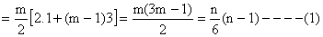
Sum of the second group;
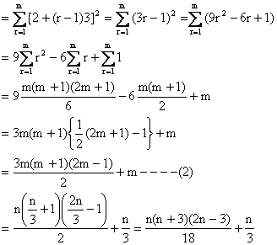
Sum of the third group =
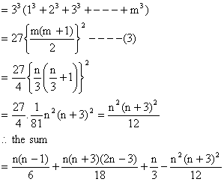
When n is divisible by 3.
If n=3m+1 i.e. When n is divided by 3. The remainder is 1. In this case the first group will have m+1 term while others will have m terms each.
∴ In (1) we shall get
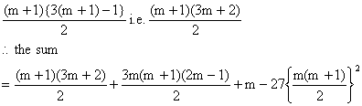
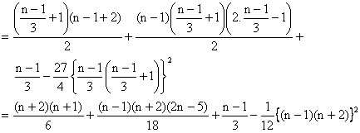
When n is of the form 3m+1.
If n=3m+2 i.e. When n is divided by 3, the remainder is 2. In this case the first and the second group will have (m+1) terms each while the third will have m terms.
∴ In (1) we shall get,
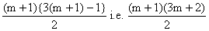
In (2) we shall get 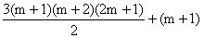
There fore the sum
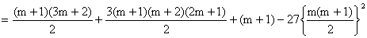(Using 3)
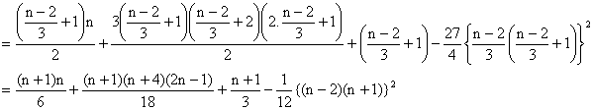
Where n is of the form 3m+2.
Dumb Question:
1) What was the need of considering three cases where n=3m, 3m+1, 3m+2?
Ans: The need for considering 3 cases arised because the last term of the series to be summed was not known to us the series was essentially three different series so to sum the series this approach of taking 3 different cases was essential.

KEYWORDS

✓ Arithmetic Progression (A.P).
✓ Common Difference.
✓ Term.
✓ Arithmetic Mean (AM).
✓ Sequence.
✓ Geometric Progression (G.P).
✓ Common Ratio.
✓ Geometric means (GM).
✓ Arithmetic Geometric Progression (AGP).
✓ Harmonic Progression (H.P).
✓ Harmonic Mean (H.M)

